**ASSIGNMENT 1**

Name: Kulsoom Khurshid

Reg #: Sp20-BCS-044

Course: Machine Learning

**Question 1)**

Adjustment of S and G:

According to the Candidate elimination algorithm, it begins with S being the null set whereas G has the entire input space.

S = < φ, φ, φ… φ > and G = <?,?,?,… ?>

S and G are updated at each instance x as follows;

* If x is positive, we generalize by removing any g ∈ G and expand s ∈ S that does not have x.
* If x is negative, we specialize by removing any s ∈ S and restrict g ∈ G that does not have x.

There are more than one way for generalization and specialization due to which we can have multiple hypothesis in S or G.

**Question 2)**

Parameters:

In case of a circle, the parameters that will be considered are center and the radius of that circle.

Parameters of circle hypothesis calculation:

To get the accurate calculations of the parameters, we need to find the tightest circle which consist of all positive examples as S known as Specific hypothesis. We also need the largest circle that consist of all positive examples but not the negative ones as G known as Generic hypothesis.

Generalization for K > 2 classes:

If K > 2 classes, one circle is not enough, we need to have circles for each class. For every class C­i we need to have the hypothesis that consist of all the elements of Ci as positive examplesand elements of Cj as negative examples where j ≠ i.

**Question 3)**

Code:

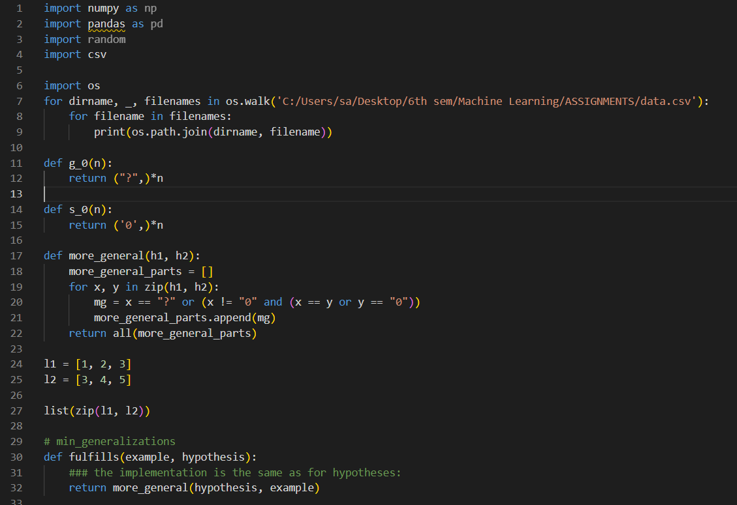

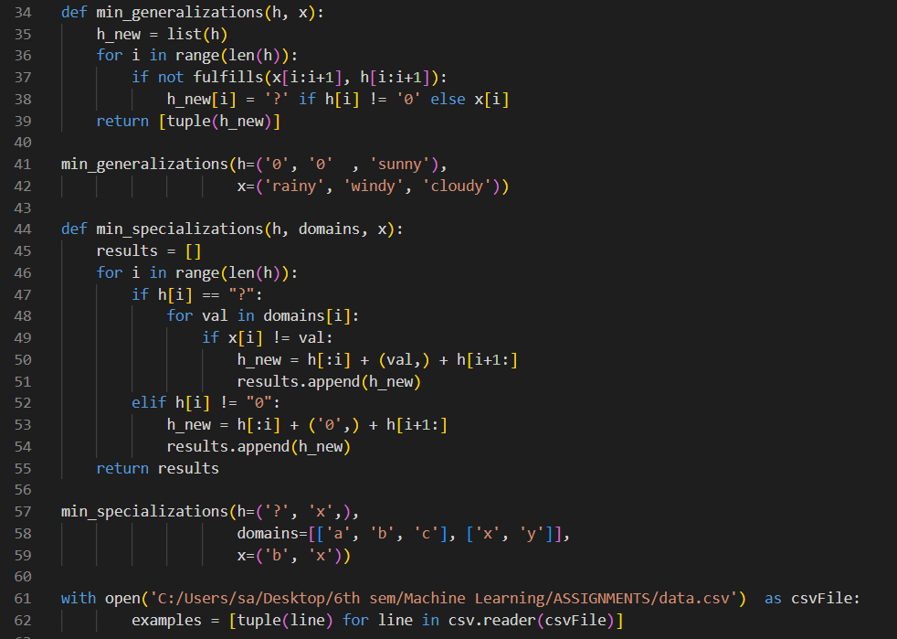

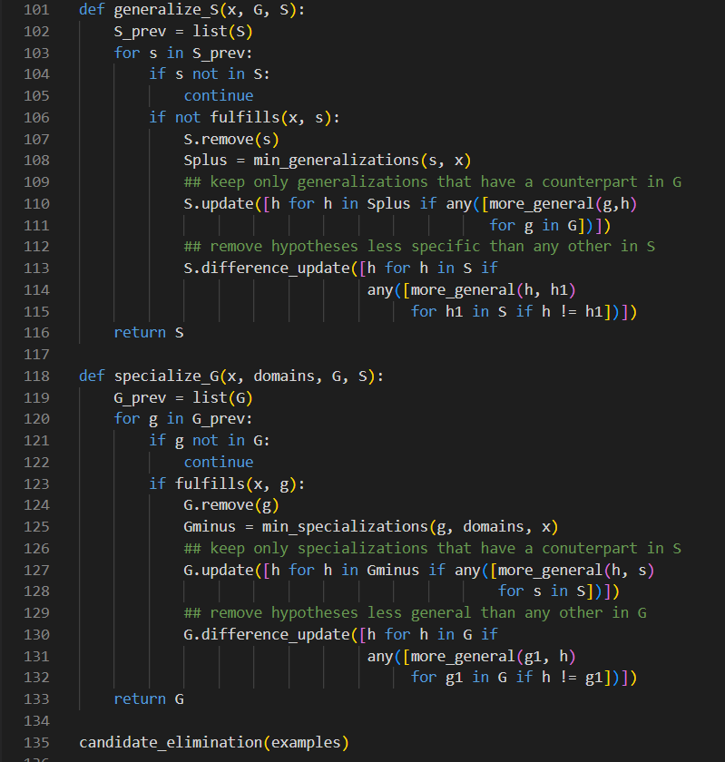

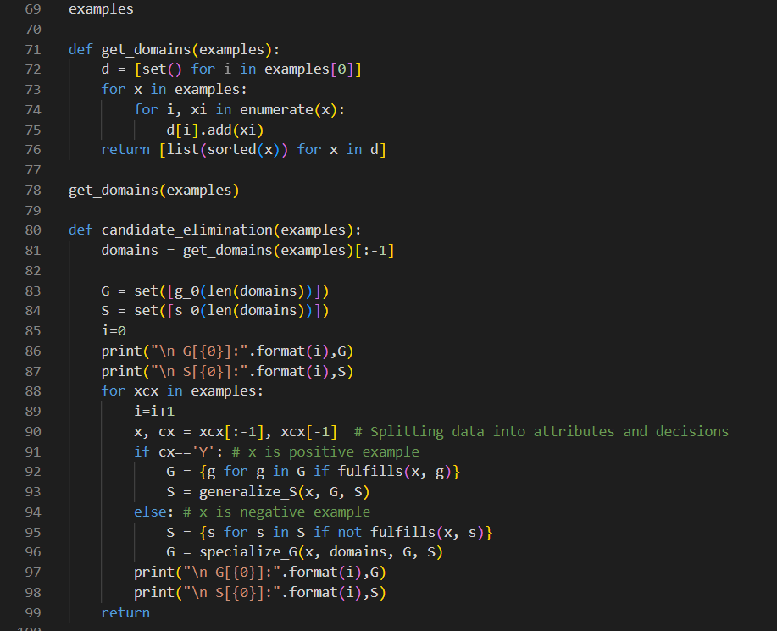

Output:

